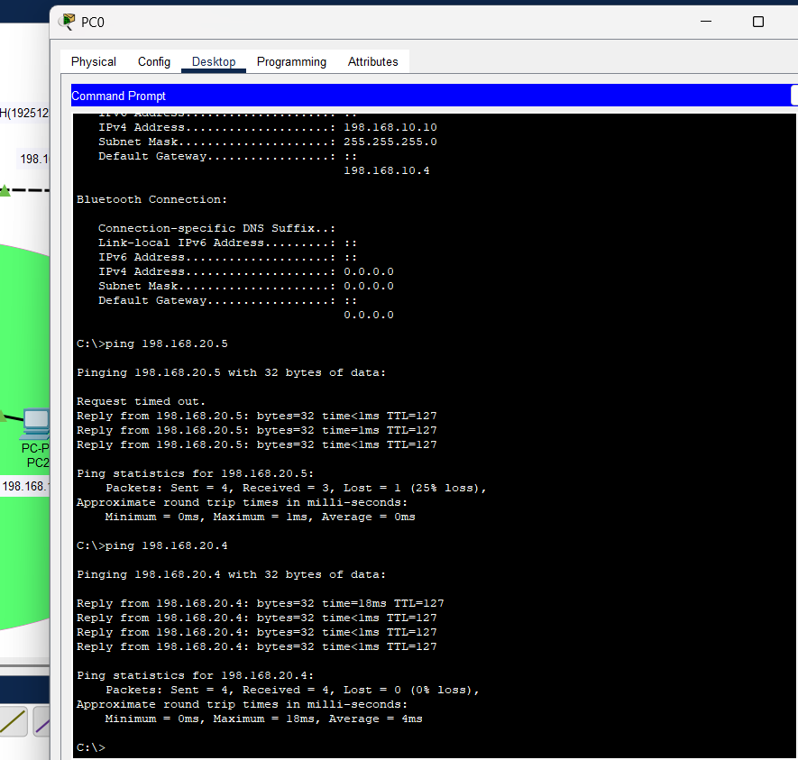
1.Implementation of inter VLAN with 2 VLANs. VLAN 10 and VLAN 20 .VLAN10 should be designed using star topology and VLAN 20 should be designed using mesh topology
